

**EE 463**

**PROJECT #1**

**Single Phase Diode Rectifiers**

**Team Members: Muhammet Emin Cinalioğlu**

**Tugay Karakaya**

**Submitted to: Ozan Keysan**

**Date:**

**Introduction**

**1)**

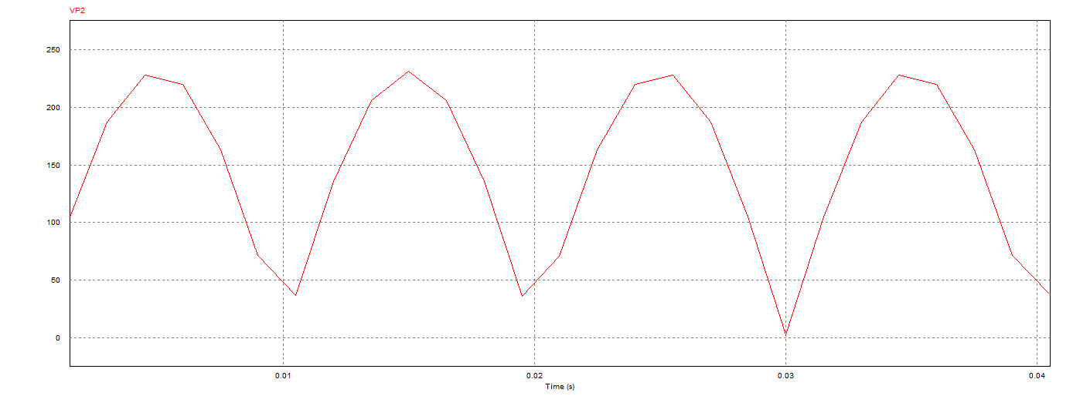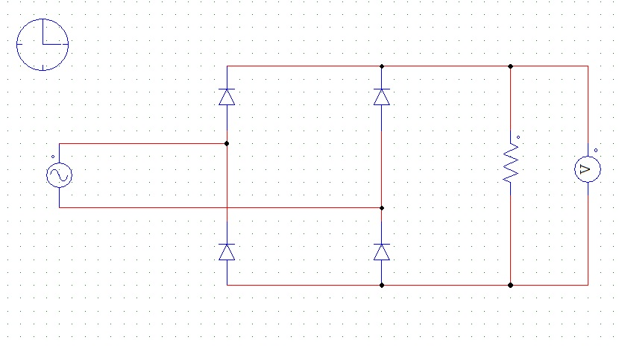The schematic and the simulation results of the single-phase diode rectifier with 100 Ω load resistance and different step sizes are illustrated in Figs. 1, 2, 3, 4.

Figure 2: The Simulation Result with 1.5 msec Step Size

Figure 1: The Schematic of the Rectifier

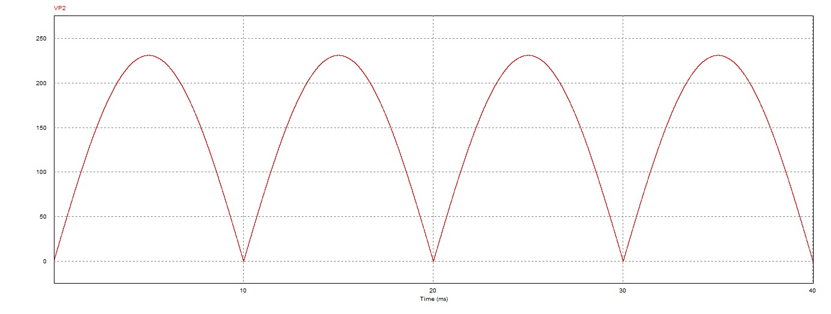

Figure 2: The Simulation Result with 10 µsec Step Size

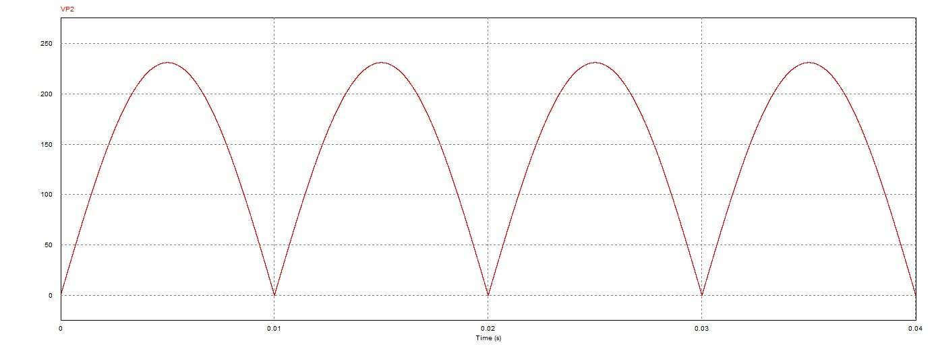

Figure 2: The Simulation Result with 1 µsec Step Size

Considering the simulation graphs, it can be obviously observed that the curves becomes smoother as the step size is decreased.